Appezite: Order ahead application and webstore generation system using blockchain: with the objective of reducing server costs

By

Rasheen Ruwisha

A REPORT SUBMITTED TO

INFORMATICS INSTITUTE OF TECHNOLOGY

AFFILIATED WITH

UNIVERSITY OF WESTMINSTER

For the Degree of

BACHELOR OF COMPUTER SCIENCE (HONS)

November 2019

Table of Contents

List of Figures 2

List of Tables 3

List of Abbreviations 4

Chapter 1: Introduction 5

1.1. Restaurant Industry 5

1.2. Online Ordering 5

1.3. Aggregate Online Ordering 5

1.4 Order Ahead Applications and Websites 6

1.5 Online ordering and business 6

1.6 Blockchain 6

Chapter 2: Literature Review 7

2.1 Overview 7

2.2 Existing and Similar Solutions 7

2.3 Review 7

2.4 Reflection 8

Chapter 3: Problem and Motivation 9

3.1 Problem 9

3.1.1 Background 9

3.1.2 General Problem 10

3.1.3 Research Question 10

3.2 Aim 10

3.3 Motivation 10

3.4 Objectives 10

Chapter 4: Methodology 11

4.1 Rich Picture Diagram 11

4.2 Methodology 11

Chapter 5: Requirements 12

5.1 Software Requirements 12

5.2 Hardware Requirements 12

Chapter 6: Project Requirement 13

6.1. Functional Requirements 13

6.2 Non-Functional Requirements 13

Chapter 7: Timeline 14

References 15

# List of Figures

Figure 1 : Toasttabs survey on most popular aggregate sites 4

Figure 2: Rich Picture Diagram 7

Figure 3 : ToastTabs survey on most used online ordering platform 8

Figure 4 : Timeline diagram 12

# List of Tables

Table 1 : Software Requirement for Development 13

Table 2: Hardware requirements from business 13

Table 3: Laptop and Mobile hardware requirements for customer 13

# List of Abbreviations

1. APK – Android Package Application
2. IOS – Internet Operating System
3. Inc – Incorporated
4. DLT – Distributed Ledger Technology
5. O2O – Online to Offline

# Chapter 1: Introduction

## 1.1. Restaurant Industry

The restaurant industry is one of the rapidly growing industries across the globe, with many new food chains opening up and increasing the competition within the industry. As the target customer base of the restaurants changes rapidly they have to come up with solutions to attract their customers. The main solution for this problem have been to have their own website or an order-ahead app which will allow to increase the restaurant sales as people prefer to order using the website or order ahead applications.

## 1.2. Online Ordering

Online ordering can be defined as a “System that allows the customers to simply and conveniently order food online”. Online ordering systems can be either an Online aggregate site or an Order ahead application/ website. According to (Razak *et al.*, 2017) Food is one of the most popular products that sell online including fast food, bakery and vitamins.

## 1.3. Aggregate Online Ordering

Aggregate online ordering solutions provide the businesses a simple way to have a delivery mechanism. With the introduction of aggregate ordering businesses and customers have been moving to the available platforms. When the business register on a site, they are then added to the list of other restaurants that will be then given as a choice for the customers to order from.

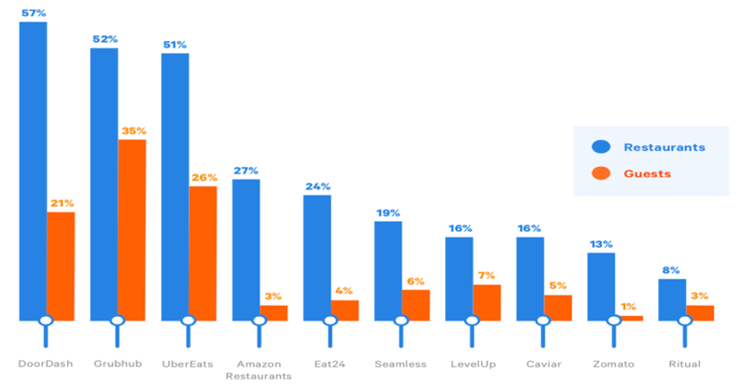Within the past year, guests ordered most on Grubhub (25%), UberEats (26%), and Doordash (21%), also those three aggregate sites have been the most popular aggregate sites among the restaurateurs according to ToastTab.(Toast Inc., 2018)

Figure 1 : Toasttabs survey on most popular aggregate sites

According to a ToastTabs survey done to collect the customer requirements for a restaurant, Guests listed online-reservations, and consumer ordering programs as restaurant technologies which are most important to improve their guest experience.(Toast Inc., 2018).

## 1.4 Order Ahead Applications and Websites

Order ahead applications and business websites allow users to order ahead of time, which allows the users to dine as they arrive, or get the order delivered to the house while allowing pay on arrival and pay on checkout. This allows businesses to increase their customer attraction.

## 1.5 Online ordering and business

Online ordering has been one of the most critical technological advancement that have been introduced to the restaurant industry. This was introduced due to the introduction of O2O model in the food and beverage industry.(Xie, 2017)

## 1.6 Blockchain

The growth of cryptocurrencies as Bitcoin, blockchain is definitely one of the hottest topics.(Satoshi Nakamoto, 2008).Blockchain serves an immutable distributed ledger that allows transactions to take place in a decentralized manner(Zheng *et al.*, 2017). The ledger is spread across the peers in the network while each of the peers hold a copy of the complete ledger which is also known as DLT.The transaction records stored in the DLT is visible at a meta level and remain tamper-resistant as identifying individual parties are difficult or impossible to achieve.(Maull *et al.*, 2017).Once a transaction is recorded it cannot be tampered as the hash computed for the block contains the hash of the previous block.(Hassija *et al.*, 2019). According to (Kim *et al.*, 2019)Blockchain allows data decentralization based on various mechanisms is considered one of the leading technologies of the next generation. While allowing it to be one of the technologies that have been able to cause disruptive changes in many of the industries due to its openness and the integrity of the data that is stored in chains.(Mohite and Acharya, 2019).Blockchain uses ﻿advanced cryptography to ensure the chaining of blocks, providing data integrity.(Košt *et al.*, 2019).Blockchains use smart contracts which are lines of code that execute when conditions are met and they provide transperancy,simplicity and efficiency.(Gopie, no date)

# Chapter 2: Literature Review

## 2.1 Overview

According to (HONG, 2016), the technological advancements in the industry have changed causing business models to grow and provide efficient systems that can help improve the productivity and profitability of restaurants using online food ordering. Online ordering has 3 perspectives, Websites, Order Ahead Applications, Aggregate sites. According to (HONG, 2016) , the mobile ordering aspect is been covered. This research helps to prove that the online ordering aspect of a restaurant is one of the most important features.

## 2.2 Existing and Similar Solutions

Applova formerly known as Apptizer has been one of the best solution providers to tackle this problem, they use a merchant web portal that allows businesses to add their products, then the users send a request to the support team to build the application for their business. Applova then manually builds the application and uploads them to the Google play store/ iOS App Store on customer demand.(Applova, no date)

UberEATS, Grubhub, Doordash have been many of the large scale Online Aggregate Ordering service provider. They allow businesses to register on their network therefore allowing customers to choose their meal from the available list of restarurants.

## 2.3 Review

The restaurants that’s use traditional food ordering systems can be classified into two categories, Verbal Based Ordering and Paper Based Ordering. According to (HONG 2016), when the area has a larger population, especially students, they tend to visit restaurant to have their meals but with their busy schedules the traditional ordering systems put them to a tough situation. This helps to prove that with the busy schedules of people they tend to order ahead of time so that they can get the order ready for them to take away when they arrive.

According to (Pantelidis, 2009) investments in the food-ordering systems have been considered to be luxury as small and medium scale businesses find it difficult to afford such systems which can operate successfully. With the advancements in the technology many creative solutions have been made to help this. The technological advancements have bought Websites, Order Ahead Applications, Aggregate site, Kiosks Terminals and many more advancements to the food industry. This proves that with the advancements the restaurants have to change accordingly to keep their customer base attracted.

With the availability of such systems restaurants have been shifting from the tadeonal ordering to online ordering as it benefits them. A similar cross-platform food delivery application was proposed by (Abid and Karim, 2017), in this system they were using MYSQL as the database for storing their data, this is not the ideal solution for the proposed system as the cost of database hosting is higher compared to blockchains that incur fees for transactions.

According to UberEATS they charge a delivery fee of a certain amount depending on the distance from the ordering place to the restaurant, a service fee of 15%, and an additional charge if the order is below 10$, and an additional service fee can be charged according to the restaurant taxes(UberEATS, 2019). Applova one of the leading Order Ahead application charges a minimum fee of $119 per month and a starting fee of $500 according to their site.(Applova, no date). As the available solutions use a database for their data storing this is reflected in the fees and other charges that are been charged. According to (Ranganthan *et al.*, 2018) statistics were compared to analyze the cost effectiveness of blockchain over databases, the tests were carried out in the Rinkeby test network, and this proved even with the gas fees to buy and sell a product is cheaper compared to existing systems like eBay. This proves that use of blockchain helps reduce service fees and other charges to a greater extend.

## 2.4 Reflection

With the service charges that are been charged by services like UberEATS, and the pricing of Order Ahead Application providers like Applova restaurants are put at a disadvantage as the cost are higher to keep the services going. The proposed solution for this is to use a blockchain based platform where the data is stored in the blockchain, according to (Ranganthan *et al.*, 2018) testing that was conducted, it shows that blockchain is one of the most suitable solutions to overcome the fees and the monthly charges. As not much solutions are available for the Order Ahead Application generation a platform using blockchain will be able to help many restaurants to get their own Order Ahead Application.

# Chapter 3: Problem and Motivation

## 3.1 Problem

### 3.1.1 Background

Online ordering has been one of the most important factors when it comes to the restaurant and fast-food industry. With the emergence of the aggregate online ordering sites and application the restaurateurs have been forced to use one of them to get more income to their business. When customers have to wait a long time to place an order or reserve a table it can turn customers away, and some may argue that they are been ignored purposely which would leave a bad remark on the restaurant.(Rarh *et al.*, 2018).Restaurants can overcome this problem with the use of online ordering, as it provides convenience to customers and overcomes the disadvantages of traditional queuing systems. (Magnani, Tilwani and Suvarna, 2017)

According to a survey conducted by (Toast Inc., 2018) Guests have listed than online reservations and consumer ordering as restaurant technologies that are most important for their guest experience. Alternatively, restaurant professionals have listed online ordering and gift card programs as some of the most important technologies for their business.

51% of the online ordering have been done using the restaurants own website, while 38% of the orders have been placed using online aggregators like Doordash, Grubhub and Uber Eats, and 29% have been placed using an app for Restaurant or a food ordering service.(Toast Inc., 2018)

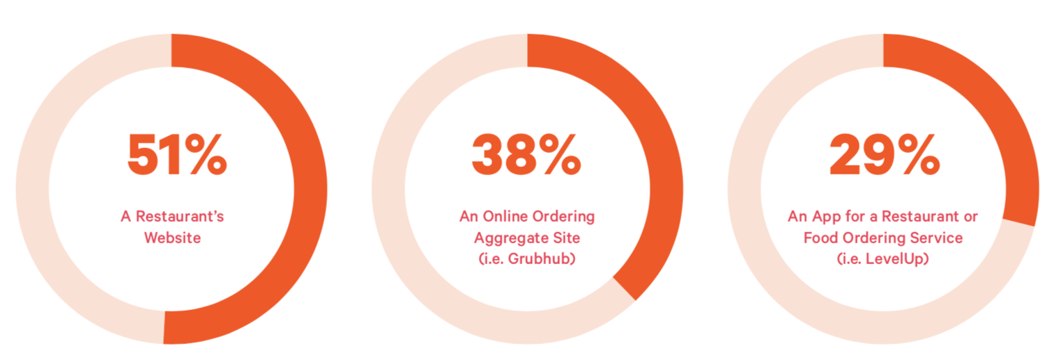

Figure 3 : ToastTabs survey on most used online ordering platform

As the amount of ordering using the restaurant websites have a 51% of customer usage the unavailability of a website will make the customers tend to find a different place to order from, so that they are able to enjoy their meals without waits.

### 3.1.2 General Problem

With the current available aggregate platforms, the restaurateurs have to pay a fee between 10% to 40% as a service fee per order, which reduces the income. The other mobile applications and websites generation platforms like Applova.inc charge a constant fee of $150(minimum) per month as a service charge disregarding the fact whether the restaurateurs have been able to get an increased sales revenue. With the service charges most of the current platforms puts the restaurateurs at a disadvantage, but the need of such an app makes the restaurateurs to stick with one of the existing platforms.

### 3.1.3 Research Question

How can blockchain can be useful eliminate monthly charges and the service fee per order?

With the use of blockchain, a decentralized way of storing data the service fee per order can be reduced to a greater extend or eliminated while allowing the monthly service charges to be eliminated, allowing the restaurateurs to have an increase in their income. Hyperledger fabric which is used in this solution will eliminate gas fees and other transaction costs. Hyperledger offers a unique approach to consensus that enables performance at scale while preserving privacy.(Hyperledger, no date).Hyperledger also offers modular architecture and uses smart contracts with the permissioned model.(Wutthikarn and Hui, 2019)

## 3.2 Aim

To allow restaurateurs to have their own online ordering website or mobile application with reduced or eliminated services fees per order and eliminated monthly service charges allowing them to increase their monthly revenue.

## 3.3 Motivation

To contribute for the success for small scale restaurants increasing their incomes, and to increase the use of blockchain. This is an attempt that is been made to achieve the target.

## 3.4 Objectives

1. To analyze how blockchain can be used to successfully provide a solution to reduce or eliminate service charges.
2. To implement a blockchain based solution to handle the problem.
3. To evaluate the fulfillment of the research objectives.

# Chapter 4: Methodology

## 4.1 Rich Picture Diagram

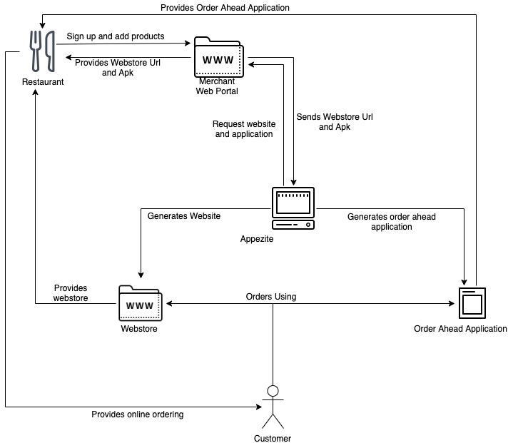

Figure 2: Rich Picture Diagram

## 4.2 Methodology

The proposed solution will use Rational Unified Process (RUP) as the development methodology as RUP provides a disciplined process to assigning tasks and responsibilities.(Corporation, 1998).Also as RUP allows iteration in each of the phases this will accommodate changes in a more manageable manner while allowing to learn along the way ensuring the overall quality of the product. According to comparison done by (AlZuhair, AlOmair and Alghamdi, 2013) they found that RUP method is better for developing system of systems.

The proposed solution will provide a Spring-MVC web portal will be provided to the restaurants to register their business, once the registration process is done the user will be allowed to add products to the business. MVC is beneficial to modularized development and greatly improves the efficiency, maintainability of system development and code reusability, which can adapt to design requirements.(Zhang, Wei and Yang, 2013)

Once products are added the Merchant Web Portal will send a request to the Appezite servers to build an APK to be uploaded to a cloud storage, while providing the restaurant with the links to download the Order Ahead Application APK and the webstore links.

Once the user is given access to the Online Ordering the users will be able to order using the platform, once the orders are being placed the restaurant will be notified via email, and a notification will be sent to the merchant web portal, once the restaurant accept the order and email will be sent to the customer confirming the order. E-mail is the most dominant method of computer-mediated communication (CMC) that used in the organizations as it more reliable and efficient and as customers want to track their order status.(Razak *et al.*, 2017)

# Chapter 5: Requirements

## 5.1 Software Requirements

|  |  |
| --- | --- |
| IDE | InteliJ, Visual Studio Code, Webstorm |
| API | Node.js |
| Webstore | Spring MVC |
| Order Ahead Application | Spring MVC |
| Merchant Webb | Spring MVC |
| Blockchain | Hyperledger Fabric, Docker, Typescript/Java |
| Programming Languages | Java, TypeScript, JavaScript, Python |

Table 1 : Software Requirement for Development

## 5.2 Hardware Requirements

|  |  |
| --- | --- |
| Description | Minimum Requirements |
| Processor | 1.6GHZ or faster |
| RAM | 2GB or more |
| Browser | Chrome, Edge, Firefox |

Table 2: Hardware requirements from business

|  |  |
| --- | --- |
| Description | Minimum Requirements |
| Processor | 1.1GHZ or faster |
| RAM | 1GB or more |
| Browser | Chrome, Edge, Firefox |
| Wifi | Yes |

Table 3: Laptop and Mobile hardware requirements for customer

# Chapter 6: Project Requirement

## 6.1. Functional Requirements

1. The system must send emails once a user register.
2. The system must send email notifications to business once orders are received.
3. The system must send email notifications to user once the order is accepted.
4. The system should auto-generate webstore once the products are added.
5. The system should be able to run scripts and build the APK for user to download.
6. The system should allow the user to increase, decrease, or remove items from cart.
7. The system should allow the user to get product delivered or picked up at the store.
8. The system should allow the user to select time of deliver or pickup.
9. The system should allow restaurants to disable and enable products.
10. The system should allow restaurant to disable delivery.

## 6.2 Non-Functional Requirements

1. The emails have to be sent with a latency of no longer than 3 minutes.
2. The processing and storing of data should be fast.
3. The webstore generation should be done immediately.
4. The APK generation should be done with a latency of no more than 1 day.
5. The total price calculation should be done before placing the order and should change according to the increase and decrease of items in the cart.
6. The delivery fees should be added and showed to the user before completion of the checkout.
7. The product enabling and disabling should be done instantly.
8. The delivery enabling and disabling should be done instantly.

# Chapter 7: Timeline

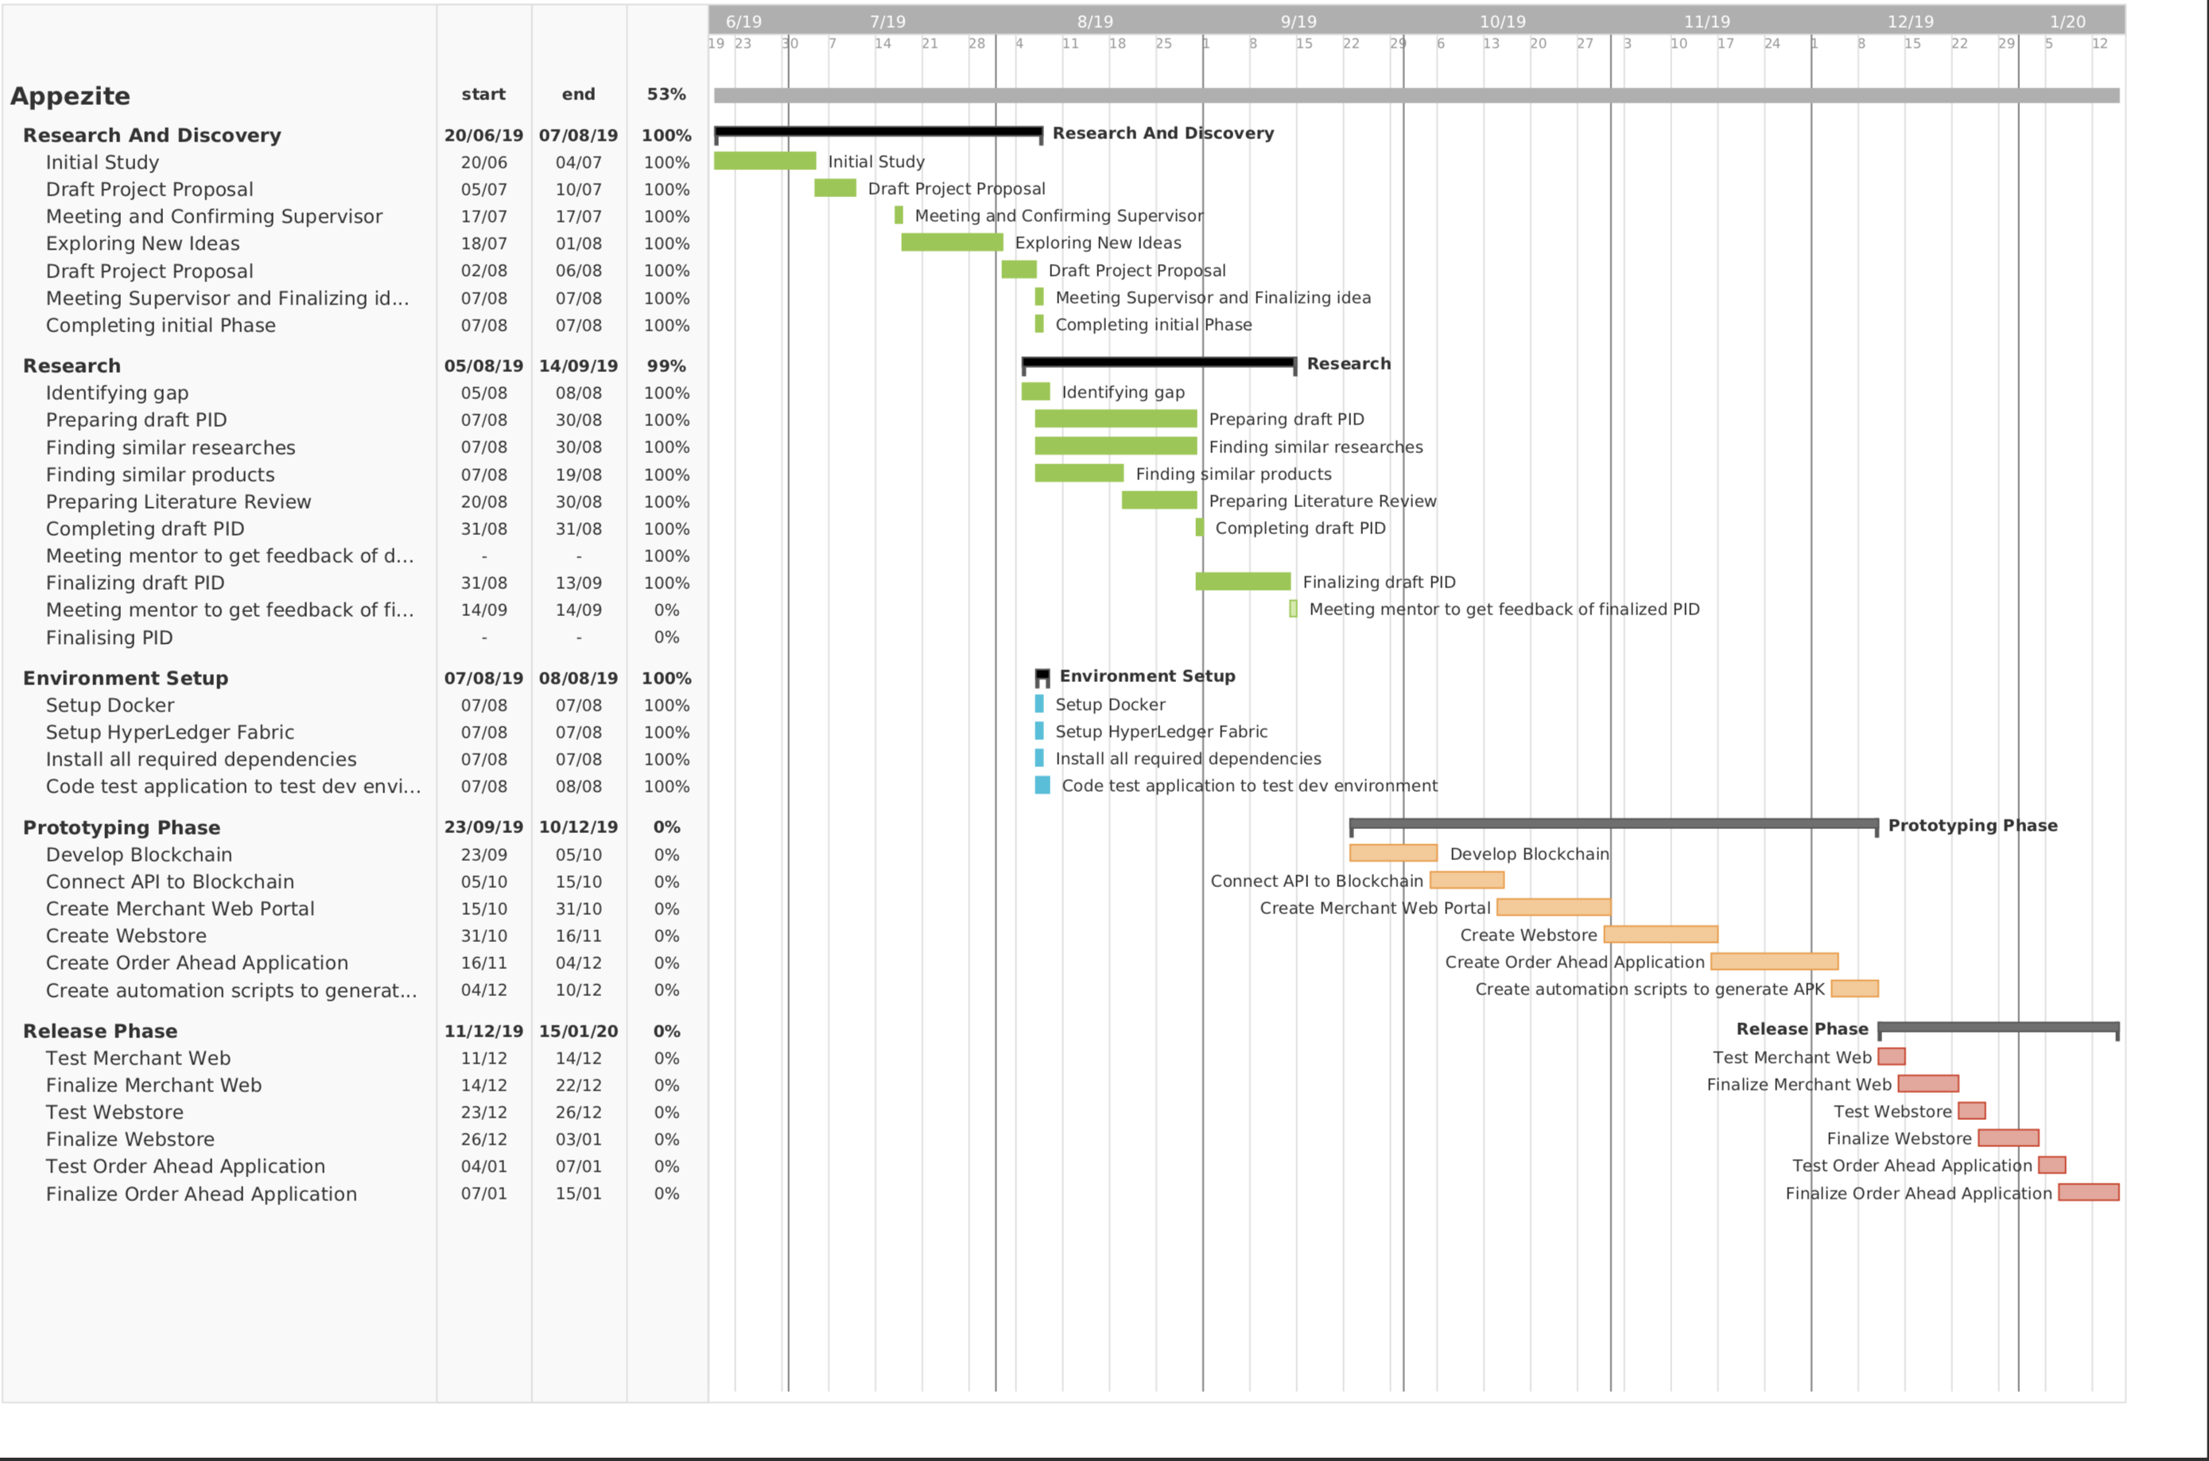

Figure 4 : Timeline diagram

# References

1. Abid, F. B. Al and Karim, A. N. M. R. (2017) ‘Cross-platform development for an online food delivery application’, *Proceedings of the IEEE International Conference on Computing, Networking and Informatics, ICCNI 2017*, 2017-Janua, pp. 1–4. doi: 10.1109/ICCNI.2017.8123769.
2. AlZuhair, M., AlOmair, Y. and Alghamdi, A. (2013) ‘A comparison of agile RUP with scrum software methods for developing system of systems:C4I system’, *Information (Japan)*, 16(12 B), pp. 8833–8842.
3. Applova (no date) *No Title*.
4. Corporation, R. S. (1998) ‘Rational Unified Process Best Practices for Software’, *Development*.
5. Gopie, N. (no date) *No TitleWhat are smart contracts on blockchain?* Available at: https://www.ibm.com/blogs/blockchain/2018/07/what-are-smart-contracts-on-blockchain/ (Accessed: 20 November 2019).
6. Hassija, V. *et al.* (2019) ‘Cryptober : A Blockchain-based Secure and Cost-Optimal Car Rental Platform’, *2019 Twelfth International Conference on Contemporary Computing (IC3)*. IEEE, pp. 1–6.
7. HONG, L. W. (2016) ‘Food Ordering System Using Mobile Phone’, 147, pp. 11–40.
8. Hyperledger (no date) *No Title*. Available at: https://www.hyperledger.org/projects/fabric (Accessed: 25 November 2019).
9. Kim, J. M. *et al.* (2019) ‘Proof of Phone: A Low-cost Blockchain Platform’, *2019 IEEE International Conference on Consumer Electronics, ICCE 2019*. IEEE, pp. 1–4. doi: 10.1109/ICCE.2019.8662107.
10. Košt, K. *et al.* (2019) ‘Blockchain E-Voting Done Right : Privacy and Transparency with Public Blockchain’, (August).
11. Magnani, A., Tilwani, J. and Suvarna, H. (2017) ‘Online Table Booking and Food Ordering System’, *IJSRD -International Journal for Scientific Research & Development|*, 5(01online), pp. 2321–613. Available at: http://www.ijsrd.com/articles/IJSRDV5I10561.pdf.
12. Maull, R. *et al.* (2017) ‘Distributed ledger technology: Applications and implications’, *Strategic Change*, 26(5), pp. 481–489. doi: 10.1002/jsc.2148.
13. Mohite, A. and Acharya, A. (2019) ‘Blockchain for government fund tracking using Hyperledger’, *2018 International Conference on Computational Techniques, Electronics and Mechanical Systems (CTEMS)*. IEEE, pp. 231–234. doi: 10.1109/ctems.2018.8769200.
14. Pantelidis, I. S. (2009) ‘High tech foodservice; an overview of technological advancements.’, *CHME 18th Annual Research Conference*, (September).
15. Ranganthan, V. P. *et al.* (2018) ‘A decentralized marketplace application on the ethereum blockchain’, *Proceedings - 4th IEEE International Conference on Collaboration and Internet Computing, CIC 2018*, pp. 90–97. doi: 10.1109/CIC.2018.00023.
16. Rarh, F. *et al.* (2018) ‘Restaurant table reservation using time-series prediction’, *Proceedings of the 2nd International Conference on Communication and Electronics Systems, ICCES 2017*, 2018-January(Icces), pp. 153–155. doi: 10.1109/CESYS.2017.8321254.
17. Razak, N. F. A. *et al.* (2017) ‘Web based online bakery system with short messaging service and email notification’, *6th ICT International Student Project Conference: Elevating Community Through ICT, ICT-ISPC 2017*, 2017-January, pp. 1–4. doi: 10.1109/ICT-ISPC.2017.8075355.
18. Satoshi Nakamoto (2008) ‘Bitcoin: A Peer-to-Peer Electronic Cash System’, *Journal for General Philosophy of Science*, 39(1), pp. 53–67. doi: 10.1007/s10838-008-9062-0.
19. Toast Inc. (2018) ‘Restaurant Success in 2018’, pp. 1–27. Available at: https://pos.toasttab.com/hubfs/Content_+_Assets/2018 Restaurant Success Industry Report.pdf?hsCtaTracking=6c15aab7-e35d-4daa-a84b-a5303191078b%7C1339e588-3f3b-4dc4-8339-265c298c09ce.
20. UberEATS (2019) *How do fees work on Uber Eats?*
21. Wutthikarn, R. and Hui, Y. G. (2019) ‘Prototype of blockchain in dental care service application based on hyperledger composer in hyperledger fabric framework’, *2018 22nd International Computer Science and Engineering Conference, ICSEC 2018*. IEEE, pp. 1–4. doi: 10.1109/ICSEC.2018.8712639.
22. Xie, B. (2017) ‘The marketing strategy research on the O2O model online order meals system in college students group’, pp. 1–5. doi: 10.1109/liss.2016.7854475.
23. Zhang, D., Wei, Z. and Yang, Y. (2013) ‘Research on lightweight MVC framework based on spring MVC and mybatis’, *Proceedings - 6th International Symposium on Computational Intelligence and Design, ISCID 2013*, 1, pp. 350–353. doi: 10.1109/ISCID.2013.94.
24. Zheng, Z. *et al.* (2017) ‘An Overview of Blockchain Technology: Architecture, Consensus, and Future Trends’, *Proceedings - 2017 IEEE 6th International Congress on Big Data, BigData Congress 2017*, pp. 557–564. doi: 10.1109/BigDataCongress.2017.85.